VOLUME MEASUREMENTS
1 cup | 8 fluid  ounces | ½ pint | 16 tablespoons | 237 ml
2 cups | 16 fluid  ounces | 1 pint | 32 tablespoons | 474 ml
4 cups | 32 fluid  ounces | 1 quart | 64 tablespoons | 0.946 ml
2 pints | 32 fluid  ounces | 1 quart | 4 cups | 0.964 ml
4 quarts | 128 fluid ounces | 1 gaallon | 16 cups | 3.8 ml
8 quarts | 256 fluid ounces | 2 gallons | 32 cups | 7.5 ml

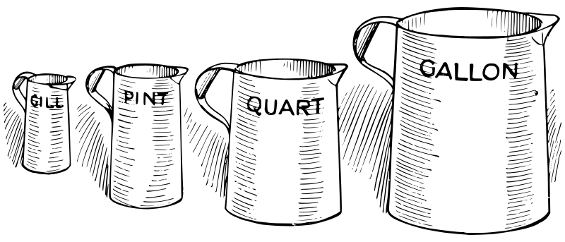
3 teaspoon | 1 tablespoon
1 tablespoon | 3 teaspoons
2 tablespoons | 1/8 cup
4 tablespoons | 1/4 cup
5 table spoons plus 1 teaspoon | 1/3 cup
8 tablespoon | 1/2 cup
10 tablespoon plus 2 teaspoon | 2/3 cup
12 tablespoon | 3/4 cup
16 tablespoons | 1 cup
32 tablespoons | 2 cups
64 tablespoons | 4 cups or 1 quart

